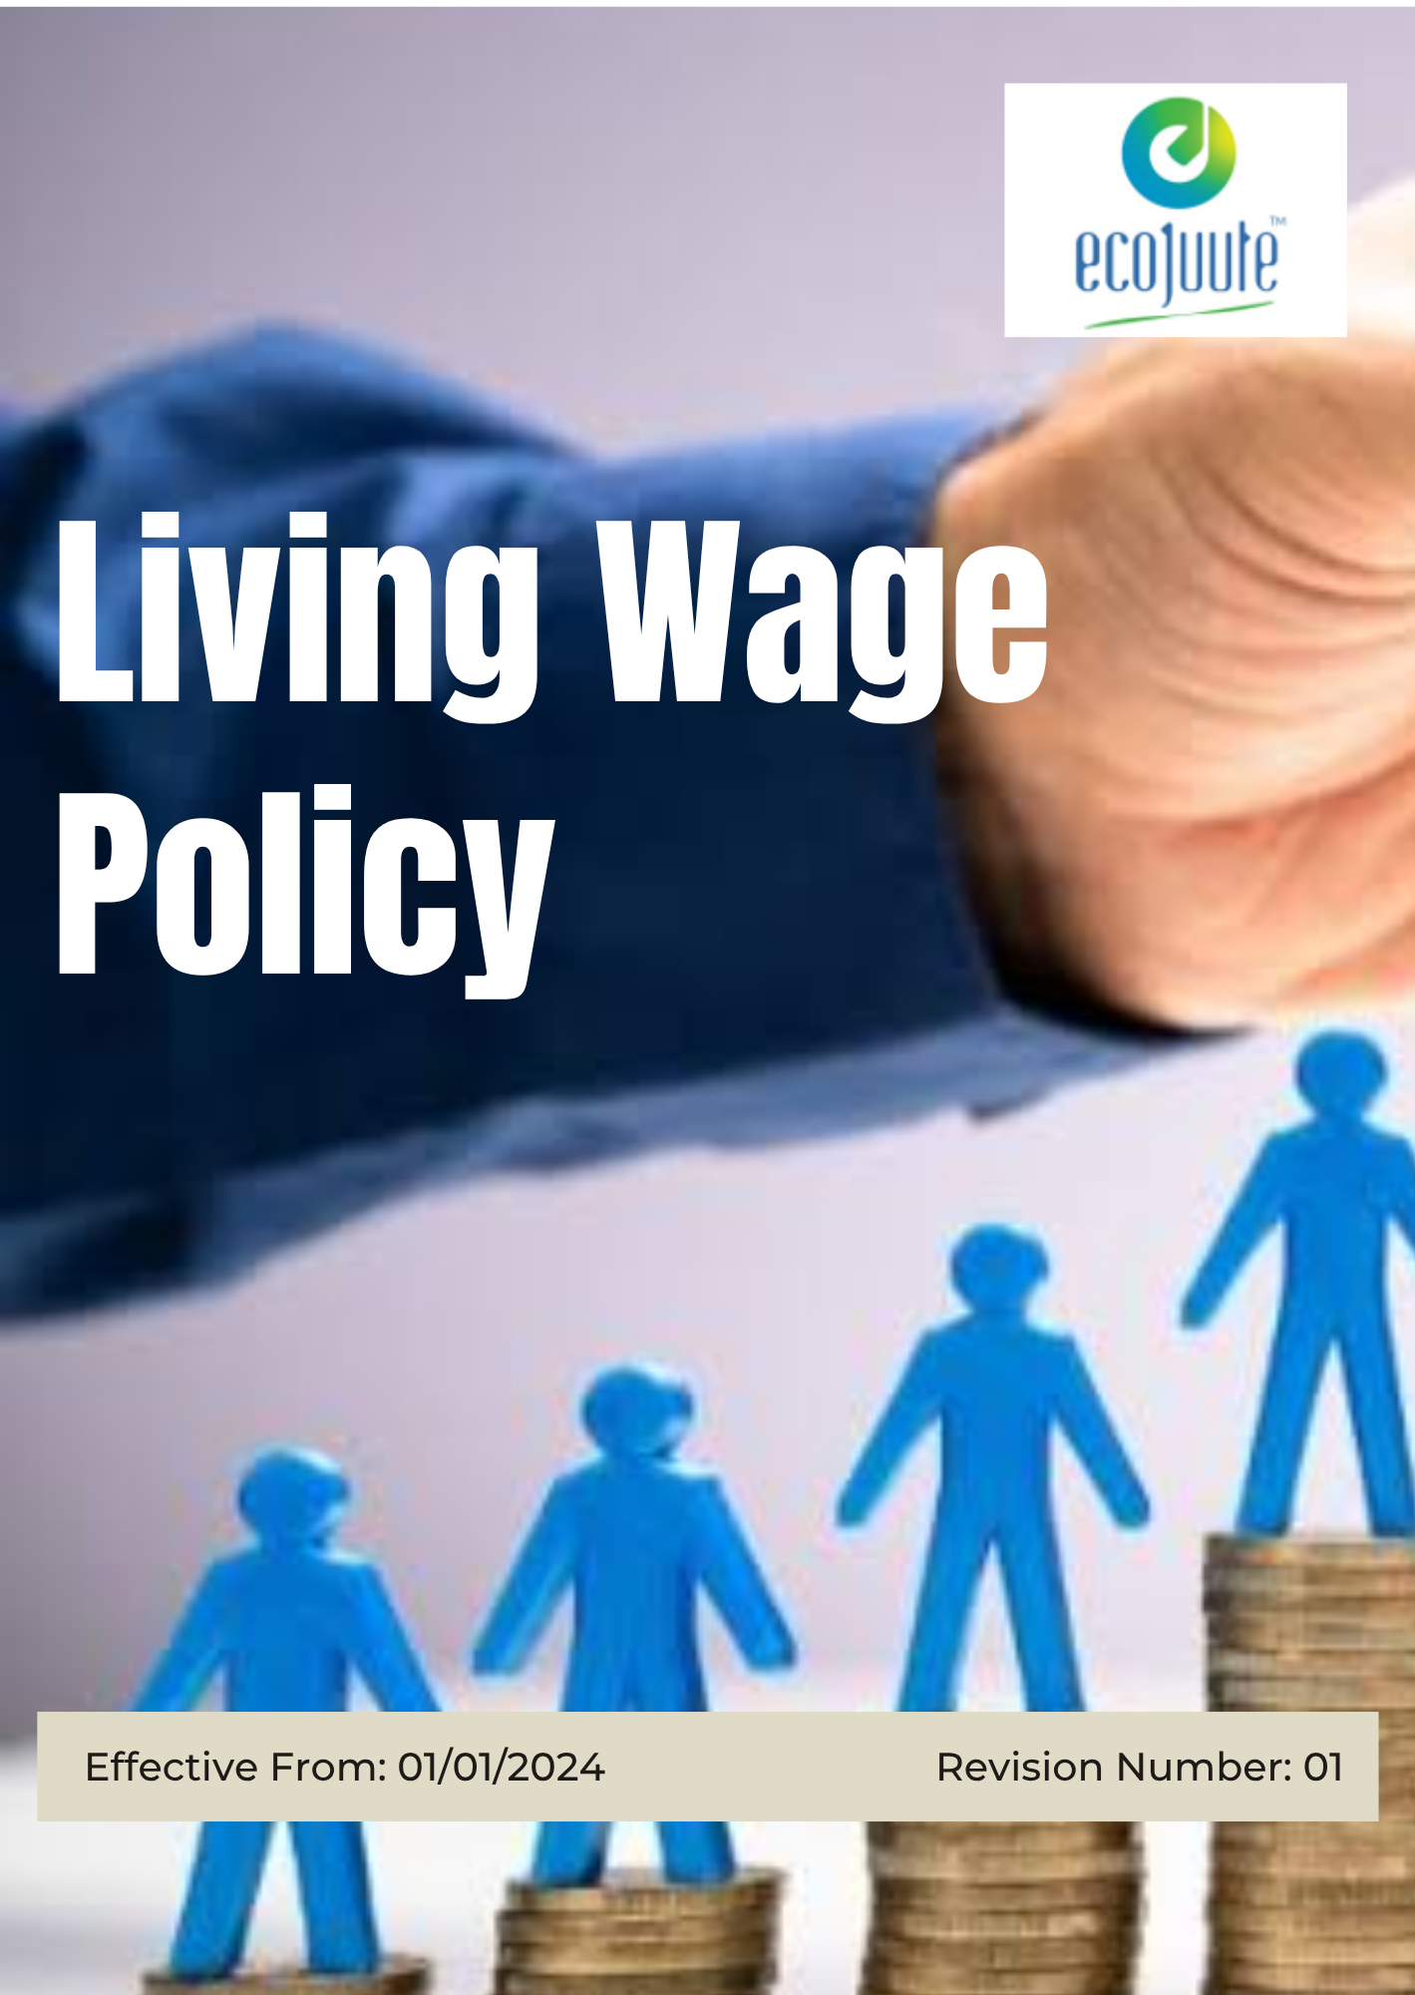
INDEX

1. Our Policy Statement 3
2. Our Approach 3
3. Scope 3
4. Living Wage Assessment & Determination 4
5. Our Living Wage Strategies & Targets 4
6. Responsibility 5
7. Monitoring, Review and Stakeholder Engagement 7
8. SDG Alignment 8
9. Review Mechanism 8
10. Employee Acknowledgement: Living wage Policy 10

Our Policy Statement
Eco Jute Pvt. Ltd. is committed to providing fair and adequate wages that support employees’ essential needs and contribute to their overall well-being. The Company seeks to promote transparent wage practices, timely payment, fair compensation, and compliance with applicable wage requirements.

The Company aims to assess wage levels against relevant living wage benchmarks and identify opportunities to progressively improve employee compensation where gaps are identified. Through responsible wage management, regular review, and continual improvement, Eco Jute Pvt. Ltd. strives to support decent livelihoods and economic well-being for its employees.

Our Approach
Eco Jute Pvt. Ltd. integrates living wage considerations into its compensation and employee management practices, alongside applicable legal wage requirements.

The Company periodically reviews wage levels against relevant living wage benchmarks, monitors identified gaps, and takes appropriate measures to support fair and adequate compensation.

Through transparent wage practices, regular reviews, employee engagement, and continual improvement, Eco Jute Pvt. Ltd. aims to promote decent livelihoods and employee well-being.

Scope
This Policy applies to all employees, contractual workers, trainees, contractors, and other personnel working on behalf of Eco Jute Pvt. Ltd. It also applies to relevant suppliers, service providers, and business partners.

The Policy covers wage practices across the Company’s operations, including wage determination, timely payment, wage reviews, living wage assessment, employee benefits, and actions to address identified wage gaps.

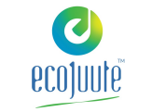 | ECO JUTE PVT. LTD.
Address:
- 6th Floor, Kankaria Estate, 6, Little Russel St, Kankaria Estates, Park Street area, Kolkata, West Bengal 700071
- Gokna Basudevpur, P.O Jadurhati, P.S- Baduria, District - 24 Parganas (North), Pin Code – 743293
 | https://www.ecojuteindia.com/contact.html

Living Wage Assessment & Determination
The living wage shall be determined through:
- Periodic assessment of cost-of-living requirements in the Company’s operating locations.
- Review of relevant living wage benchmarks and industry wage data.
- Consideration of applicable local economic and household cost indicators.
- Consultation with employees and their representatives, where appropriate.
- Periodic review to identify and address any significant gaps between actual wages and living wage levels.

Our Living Wage Strategies & Targets
- Establishes 2023 as the Baseline year for measuring progress and achievements in our initiatives.

- Living wage Assessment: Complete a living wage benchmark assessment covering 100% of employees by Year 2030, using Year 2023 as the baseline Year.
- Benefits Equity: Improve the consistency and fairness of employee benefits by 12% by Year 2030, compared with the baseline Year 2023.
- Living Wage Coverage: Ensure 100% of employees receive wages at or above the established living wage level by Year 2030, based on relevant local benchmarks and using Year 2023 as the baseline Year.
- Pay Equity: Reduce disparities in bonus distribution between higher-paid and average employees by 20% by Year 2030, compared with the baseline Year 2023.
- Minimum Wage Compliance: Maintain 100% compliance with applicable minimum wage requirements across all locations by Year 2030, using Year 2023 as the baseline Year.

Responsibility
- Senior Management
- Provide overall direction and oversight for the implementation and effectiveness of the Living Wage Policy in alignment with the Company’s values and applicable requirements.
- Provide adequate resources to support fair compensation, employee welfare, wage assessments, and improvement initiatives.
- Review living wage performance, objectives, targets, identified wage gaps, and significant risks through periodic management reviews.
- Ensure appropriate corrective actions are implemented where wage gaps or compliance concerns are identified.

- Human Resources (HR) Manager
- Coordinate the implementation and periodic review of the Living Wage Policy and related procedures.
- Ensure compliance with applicable minimum wage, wage payment, and employment requirements.
- Conduct or coordinate periodic living wage assessments and benchmark employee wages against relevant living wage standards.
- Maintain accurate records relating to wages, benefits, working hours, and other relevant compensation information.
- Identify wage gaps and recommend appropriate actions to progressively improve compensation.

- Sustainability & Compliance Officer
- Support living wage assessments, risk reviews, and compliance evaluations where applicable.
- Monitor progress against living wage objectives and targets and report significant findings to management.
- Review relevant living wage benchmarks, industry practices, and applicable requirements.
- Support the monitoring and closure of corrective actions related to identified wage gaps or compliance concerns.

- Finance Department
- Ensure employee wages are accurately calculated and paid within the established payment timelines.
- Maintain appropriate payroll records and supporting documentation.
- Support HR in providing wage data required for living wage assessments and reviews.
- Promptly report identified payroll discrepancies or wage-related concerns to HR for resolution.

- Employees and Contractors
- Comply with applicable employment and wage-related procedures.
- Review and report any concerns regarding wages, benefits, deductions, or payment through established channels.
- Participate in relevant employee engagement, wage surveys, and living wage assessments where required.
- Support the Company’s commitment to fair, transparent, and responsible compensation practices.

Monitoring, Review and Stakeholder Engagement
- Regular Wage Compliance Reviews
- Eco Jute Pvt. Ltd. shall conduct periodic reviews of wage practices to assess compliance with applicable wage requirements and progress against Living Wage Policy objectives. Reviews shall include:
- Wage Compliance: Verification of wage payments against applicable legal requirements and established living wage benchmarks.
- Wage Adequacy: Assessment of identified gaps between employee wages and relevant living wage levels.
- Employee Feedback: Review of employee feedback relating to wage fairness, adequacy, and compensation practices.

- Internal Reviews and Audits
- Internal reviews or audits shall be conducted periodically to evaluate implementation of the Living Wage Policy and effectiveness of wage management processes.
- Reviews shall assess wage calculations, payment practices, records, and compliance with established requirements.
- Identified gaps shall be documented and followed by appropriate corrective actions and improvement measures.

- Stakeholder Engagement
- Eco Jute Pvt. Ltd. shall engage with employees, employee representatives, payroll personnel, and other relevant stakeholders on living wage matters.
- Feedback and concerns relating to wages, benefits, and compensation practices shall be recorded, reviewed, and addressed appropriately.
- Relevant findings, improvements, and changes to living wage practices shall be communicated to applicable stakeholders.

SDG Alignment
 |  |  | 

Review Mechanism
- Annual Performance Review:
- Living wage objectives, targets, and key performance indicators relating to wage levels, wage compliance, employee benefits, identified wage gaps, and compensation practices shall be reviewed annually.
- Progress against established targets, wage performance, compliance status, employee feedback, and improvement initiatives shall be evaluated through periodic Management Review Meetings.
- Key achievements, challenges, wage gaps, risks, and opportunities for improvement shall be identified and documented.

- Continuous Improvement:
- Findings from wage assessments, payroll reviews, internal audits, employee feedback, and stakeholder engagement shall be used to identify opportunities for improvement.
- Corrective actions shall be implemented where wage gaps, payment issues, non-compliances, or other compensation-related concerns are identified.
- Living wage objectives, targets, assessment methods, and compensation practices shall be reviewed periodically to support fair and adequate wages.

- Policy Review and Update
- The Human Resources (HR) Manager shall review this Policy at least once every two years, or earlier where significant changes occur in wage laws, business operations, living wage benchmarks, workforce requirements, or stakeholder expectations.
- Proposed revisions shall be reviewed and approved by Senior Management before implementation.
- Approved changes shall be communicated to relevant employees, contractors, and other applicable stakeholders, with appropriate awareness or training provided where required.

- Revision History
Revision No. | Revision Date | Description of Change
00 | 01-01-2024 | Initial release of the Living wage Policy
01 | 01-01-2026 | Revised a formal Revision History table

(Signature)
Approved By:
Designations:
Last Review Date: 01-01-2026 Next Review Date: 01-01-2027

Employee Acknowledgement: Living wage Policy
- I acknowledge that I have received, read, and understood the Living Wage Policy of Eco Jute Pvt. Ltd. I am aware of the Company’s commitment to fair, transparent, and adequate compensation and to supporting employee well-being through responsible wage practices.
- I understand my responsibility to comply with the Policy, provide accurate information where required for wage assessments, and raise any concerns relating to wages, benefits, deductions, or payment practices through established channels.
- I further acknowledge my role in supporting the Company’s objectives and targets relating to living wage assessment, minimum wage compliance, fair compensation, benefits equity, and the continuous improvement of wage practices.
- By signing below, I confirm my commitment to complying with the requirements of this Policy and supporting Eco Jute Pvt. Ltd.’s commitment to fair and responsible compensation practices.

Employee Name: ______________________
Department: _______________
Date: _______________
Employee Signature: ____________________

